1.
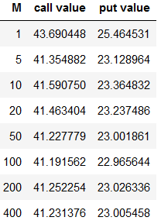

M can be a very large value tending to infinity.
The values converge to Black-Scholes model call option value(41.2306).

2.
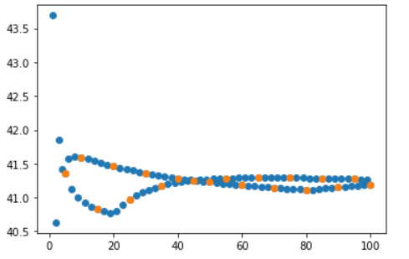
call:

put:

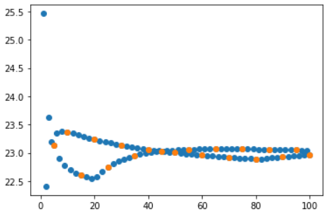

M converges faster in steps of 5 than in steps of 1 to the Black-Scholes model call option value

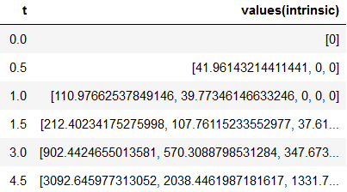
3.

